CIS 634 Object Oriented Software Engineering
Course Project

TICKETING TOOL
GROUP – 4

Software Design Specification for Ticketing Tool Project

SOFTWARE DESIGN SPECIFICATION

- Introduction:
All inbound IT-related requests from customers and other corporate divisions are handled using an IT ticketing Tool. Every support request will be turned into a separate ticket by its design, which also streamlines the support procedure through features like ticket management, enhanced collaboration, automation, and others.
Here are some additional goals you can accomplish with powerful IT ticketing software:
- Bring all your support inquiries from various channels together on one platform.
- Consolidate various inboxes into a shared inbox that all your agents may access.
- specialists with tickets and monitor their progress.
- Track and evaluate important support metrics.
- Obtain customer feedback to enhance your IT support procedures.
1.1 Goals and objectives
Now, the main objective of every service provider would be to provide trustworthy support to end users, which is essentially the same. However, you can set more focused objectives, such maximizing first-contact resolutions or reducing the time it takes your support staff to respond to a problem.
Once your objectives are clear, you may create a strategy to accomplish them. To ensure that everyone is on the same page, it is also crucial to write down and discuss these goals with the relevant team members.

1.2 Statement of scope
A description of the software is presented. Major inputs, processing functionality, and outputs are described without regard to implementation detail.
The Ticketing Tool allows user to raise tickets which will state a problem the user facing and looking for solution for the respective problem which they are facing, and whenever a ticket is raised by the customer it is stored into a Database for that we are using A free PHP utility called phpMyAdmin is designed to manage the administration of a MySQL or MariaDB database server. Most administrative activities, such as building a database, performing queries, and adding user accounts, may be completed with phpMyAdmin.
Now days this tool has been used in many aspects 85% of the IT companies are using Ticketing Tool to rectify the user problems which they are facing with.

1.3 Software context
Organizations need a way to handle employee issues that is different from emailing and contacting IT departments with requests or going to IT specialists in person to discuss the issue. All service inquiries are combined into a single point of contact using ticketing software.
All HR, legal, IT, and other inquiries can be stored and managed in these ticketing systems. Additional features and advantages include:
- Increased employee satisfaction and communication
- IT productivity growth
- Information that is pertinent, reliable, and consistent is all available in one place
- Access to a central database
- Choices for self-service
- Data in real-time for analytics and reporting

1.4 Major constraints
When using a traditional ticketing system, some of the most common issues are impersonal service, inadequate response times for critical issues, limited availability of services during specific hours, and inability to resolve even the simplest of queries right away.
2.0 Data design and Database description
phpMyAdmin a utility used to manage the administration of MySQL server where all application data is stored for you have to open phpMyAdmin portal from following link: http://127.0.0.1/phpmyadmin/index.php
After, we need to create a database in the portal:

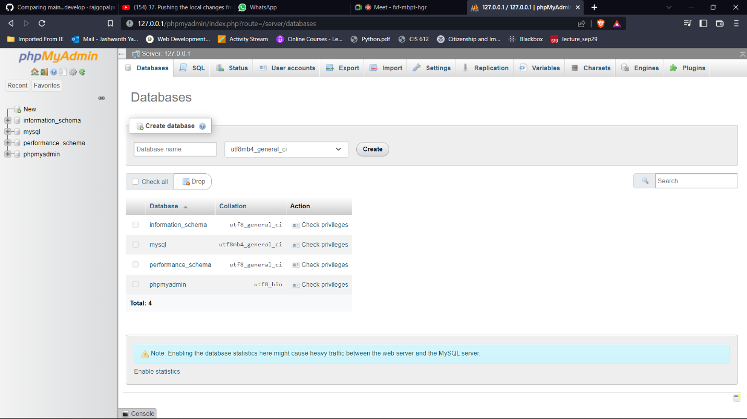

We need to create a database

Give same database name mentioned in MySQL server

We can see the database created in the following screenshots:
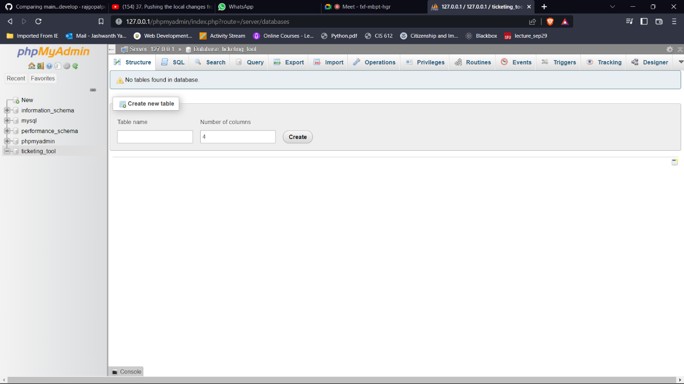
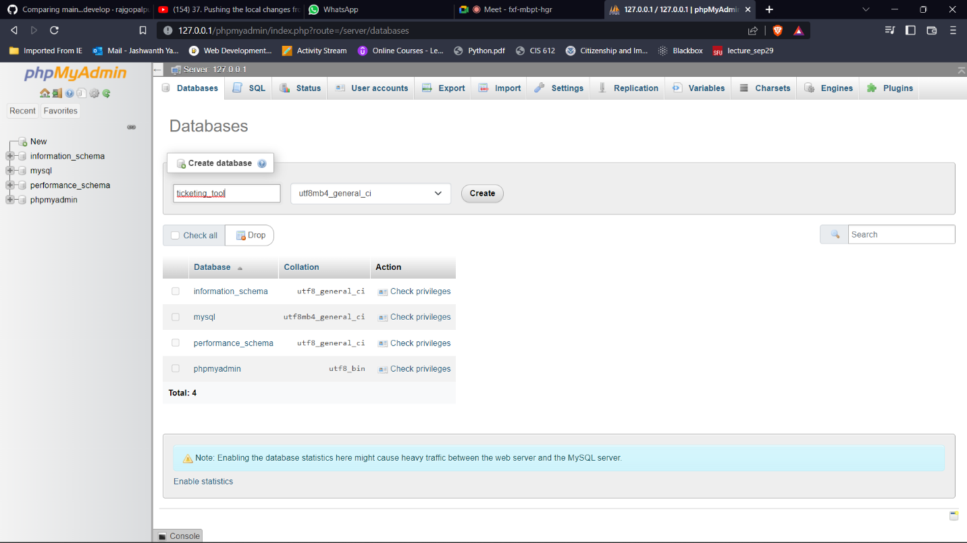

Database has been created

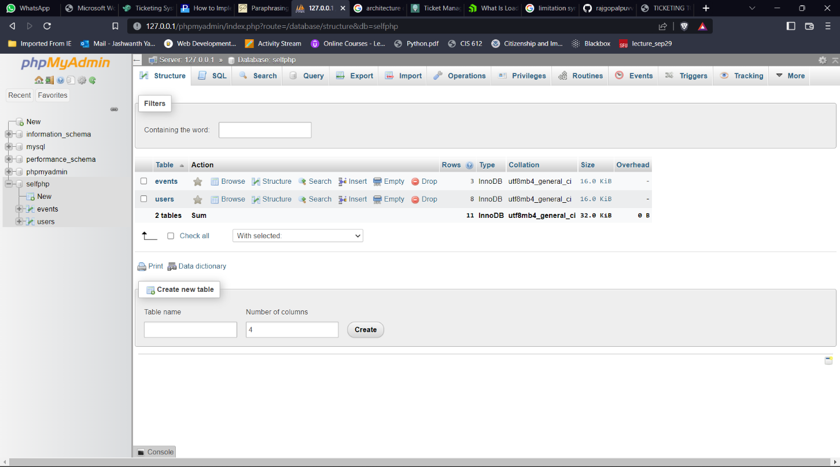

Once the database has been created now, we need to create tables, attributes for the tables and define the primary key, foreign key, and unique key for each table

2.1 Data structures
To perform and store all essential data, we primarily employ Character and Integer data types. The character data type is used to store all string-formatted inputs. And we are using datetime module which allows to track the ticket created by user like when it was created and when the ticket was solved. Also, we used the longtext datatype for user message or description to state problem which the user is facing.

The Database schema as follows:
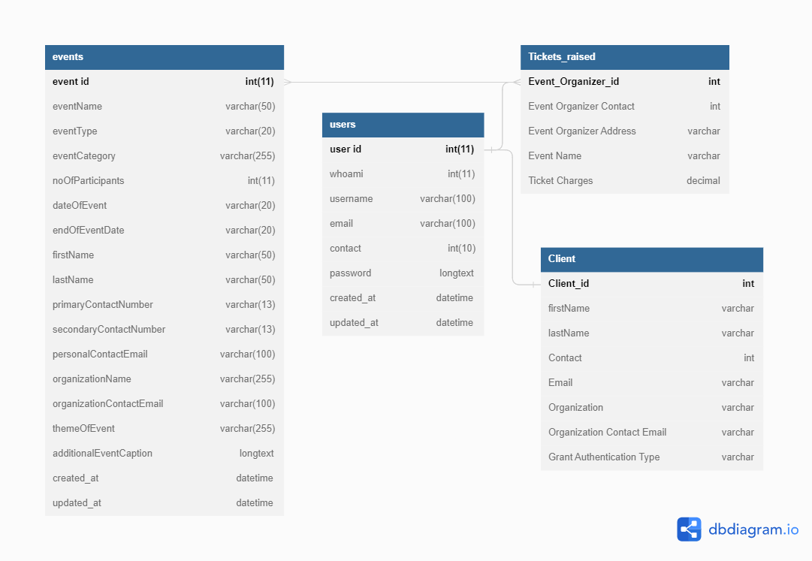

3.0 Architectural and component-level design
Clients are nothing but the end user who raise tickets once the ticket is raised which basically sends a request to different application server and the request is sent based on the incoming traffic to server for example, is a server is busy then it transfers the request to another server this technique is called Load Balancing.

The framework of load balancer:
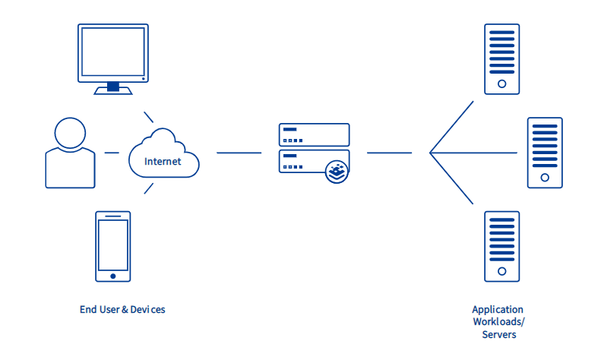
Load Balancer

3.1 Architecture diagrams
Clients are simply end users who raise tickets. When a ticket is raised, a request is sent to a different application server based on incoming traffic; for instance, if a server is busy, the request is transferred to another server.
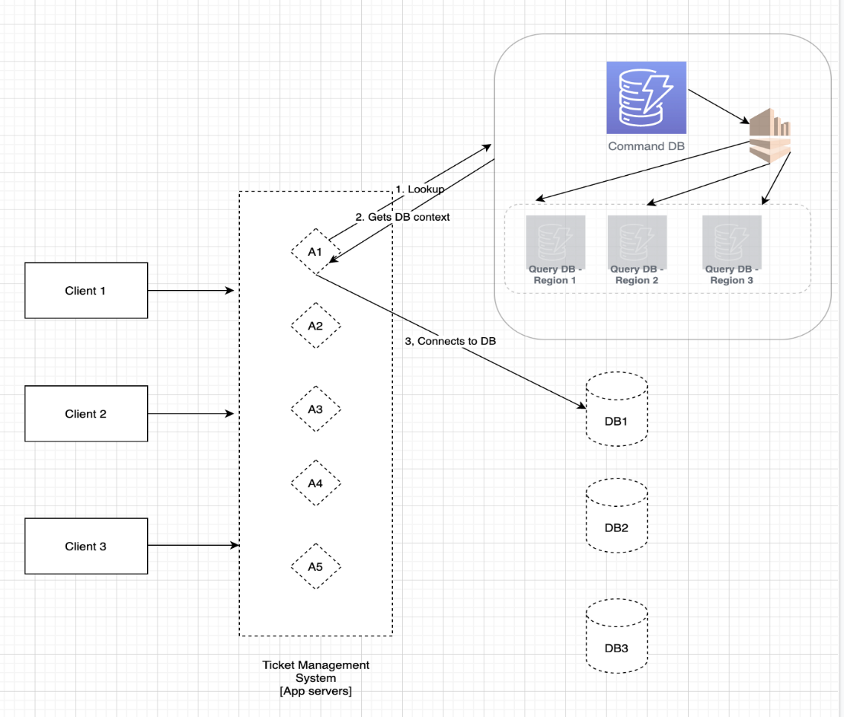
3.2 Description for Components
This is divided into four components:
- Ticket Management
- Client Management
- Event Management
- User Management

3.2.1 Component n description
3.2.1.1 Interface description
Login:
Which includes the username and password when entered the software checks the respective entered username and password are correct or not
This technique is called Validations
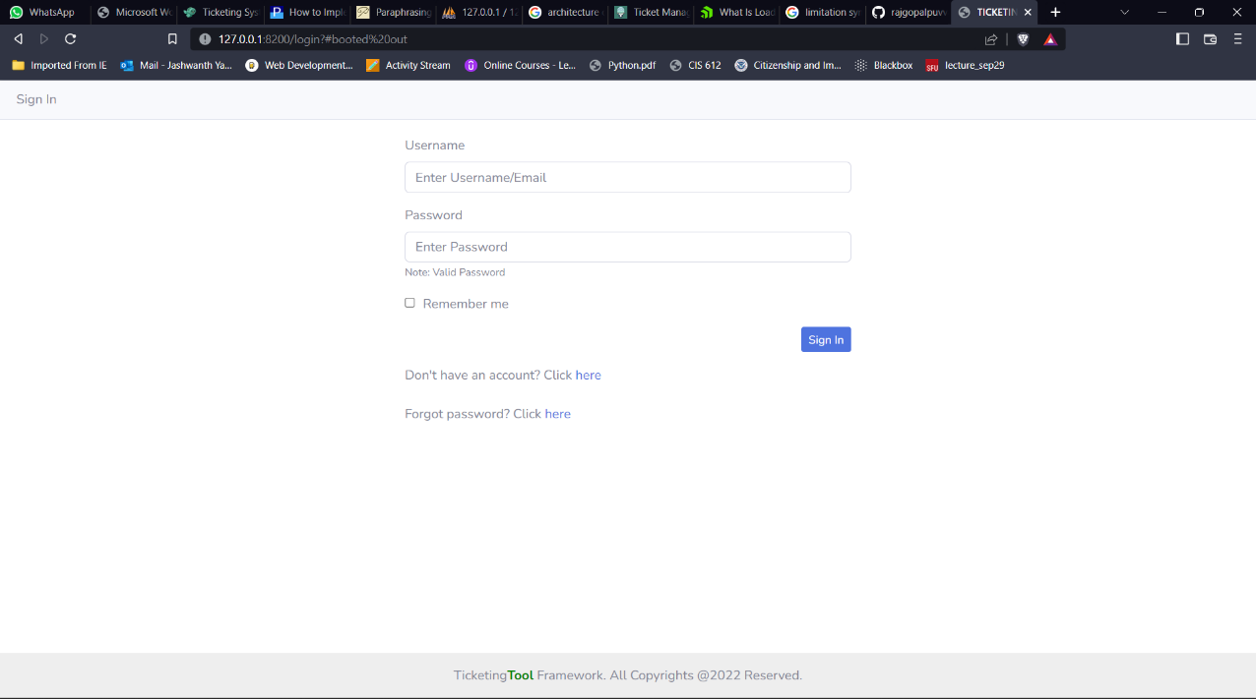
If not a user, then User Registration Page:
Not a user then then need to register by providing the details like ID, name, email, contact information, password.
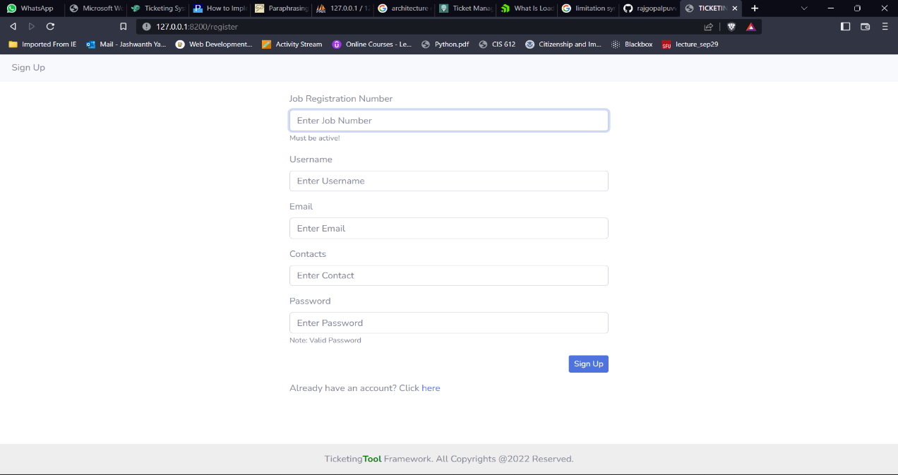
3.2.3.2 Static models
Dashboard is only static page where we can the track the data like created tickets, managing events, etc.
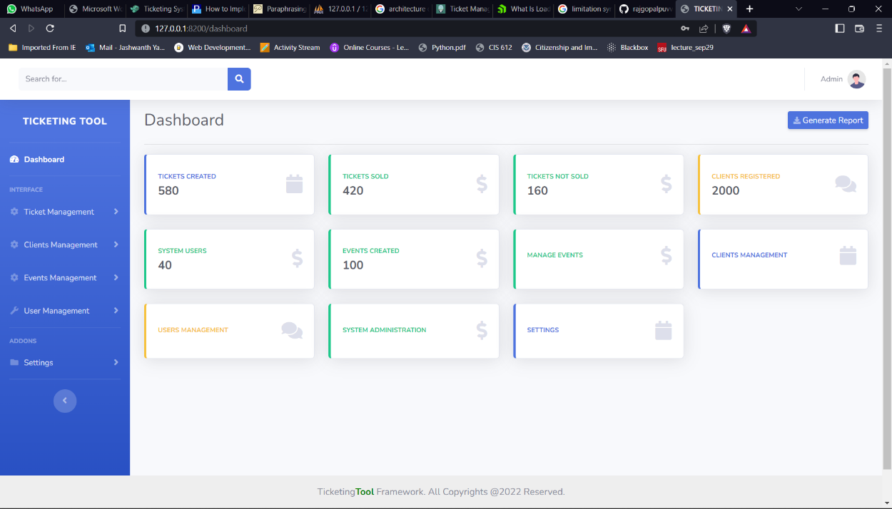

3.2.3.3 Dynamic models

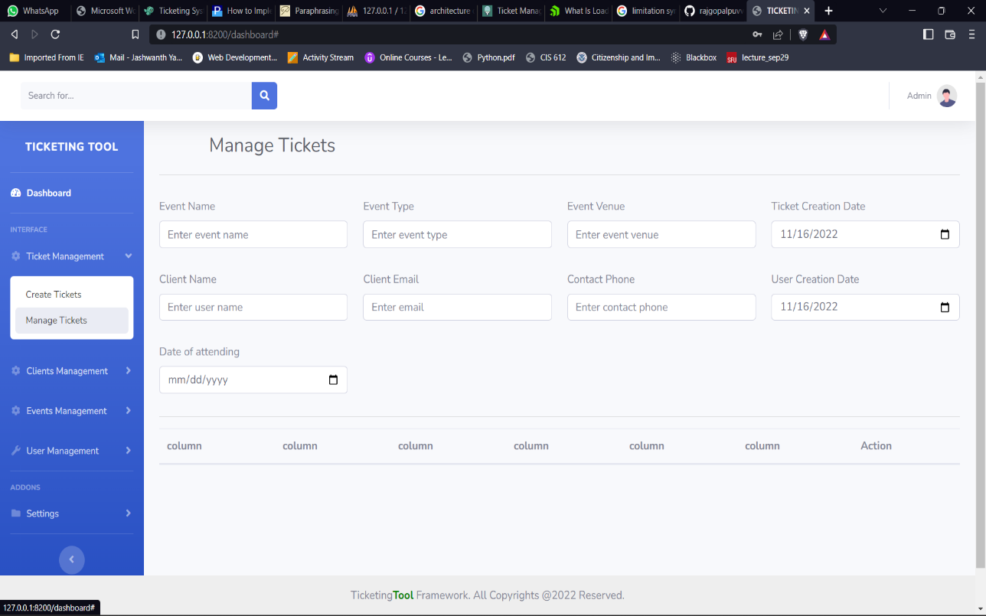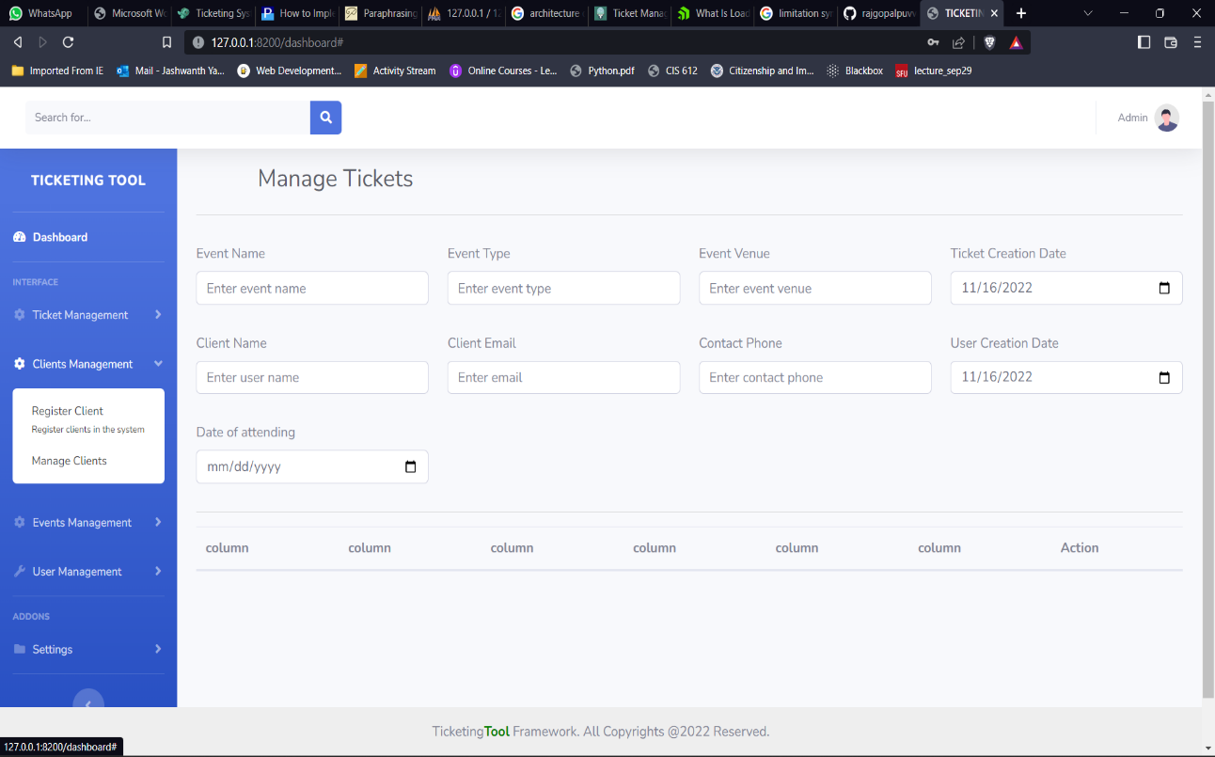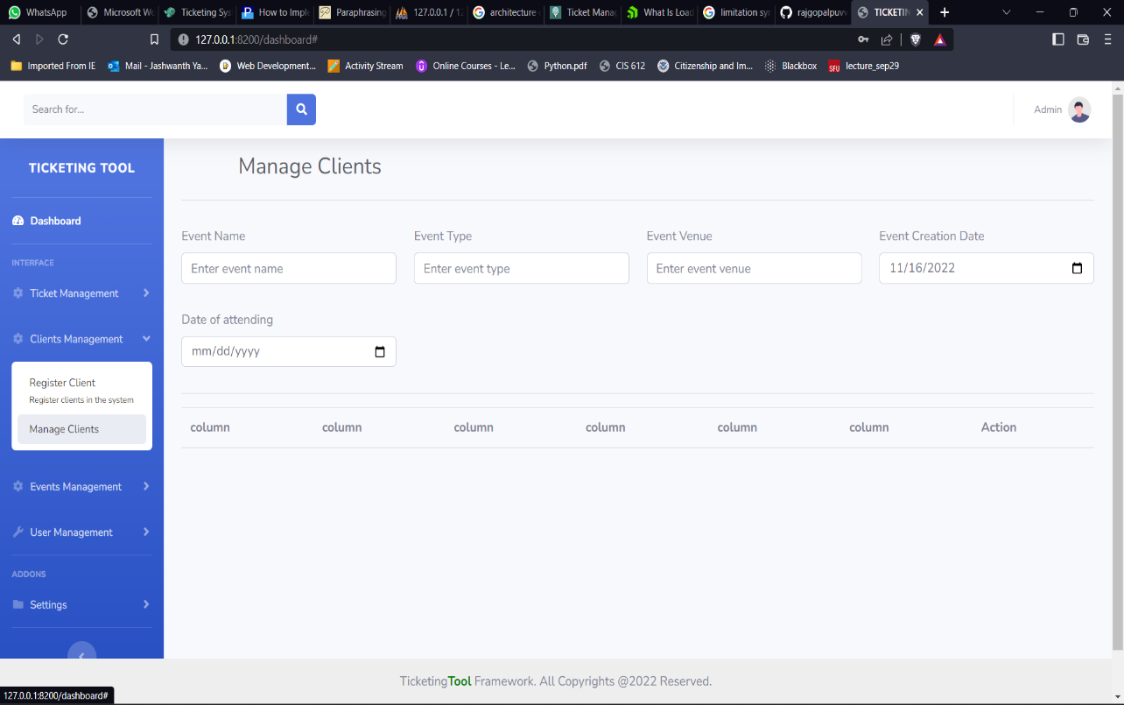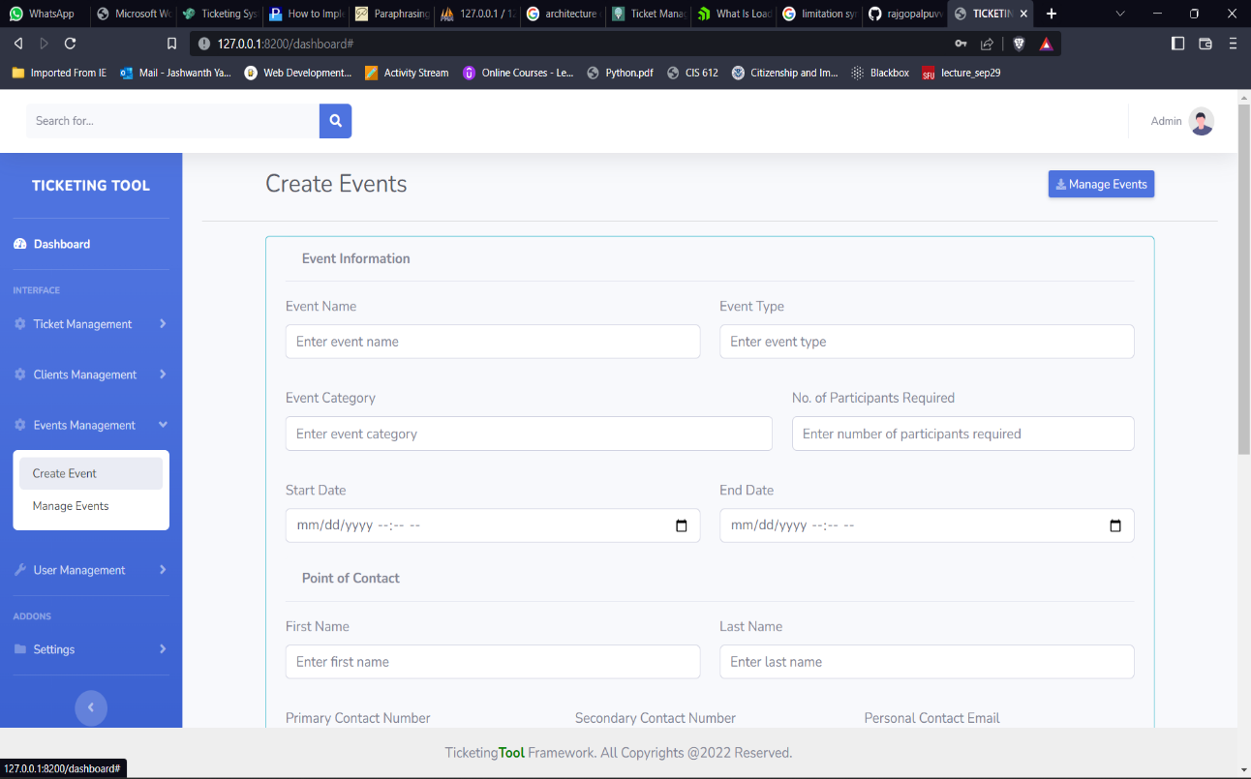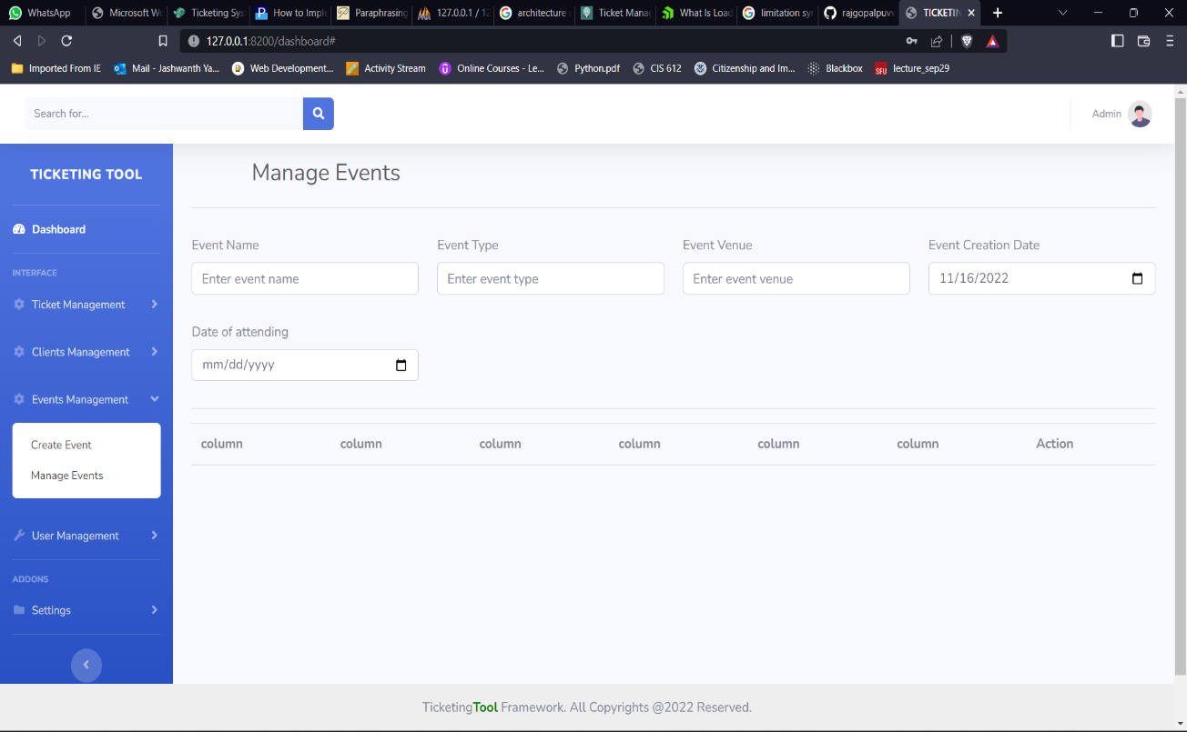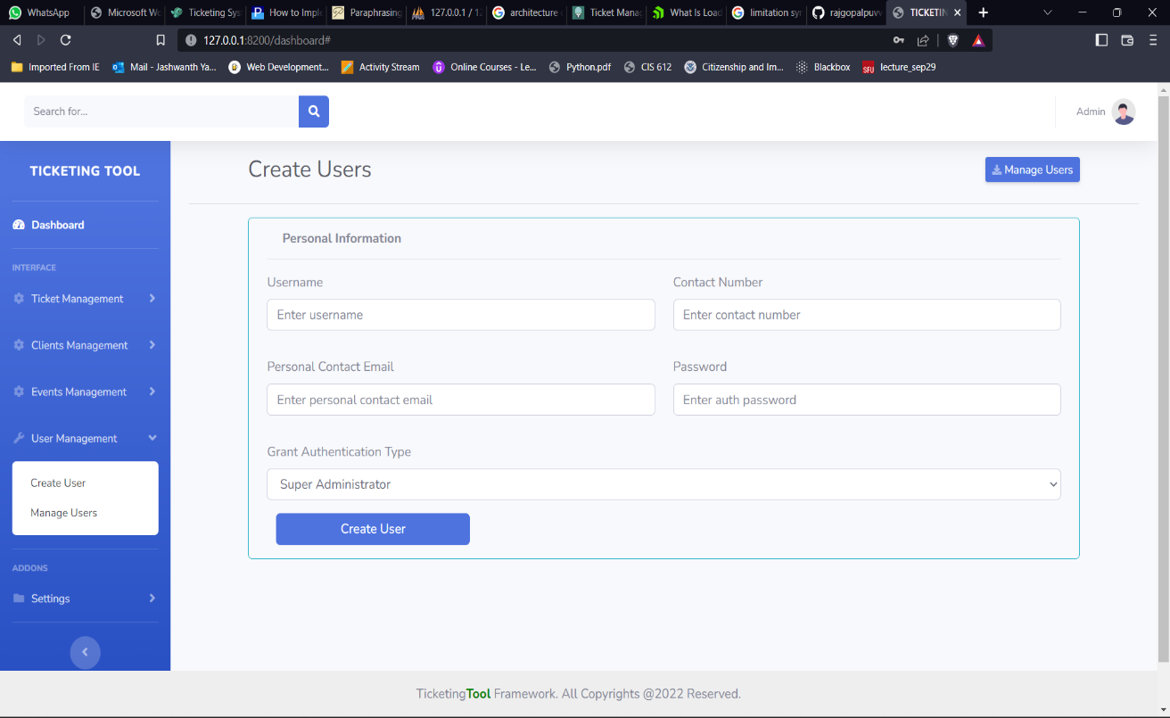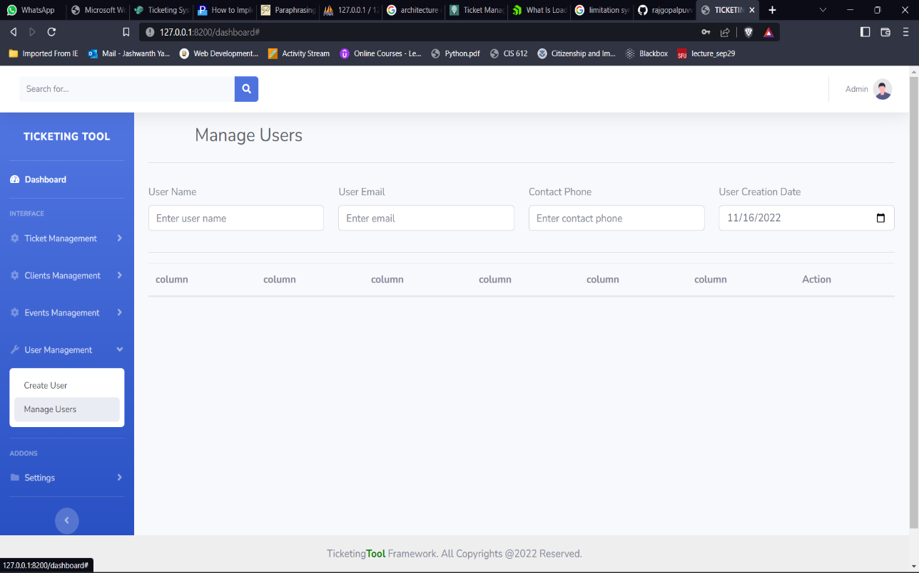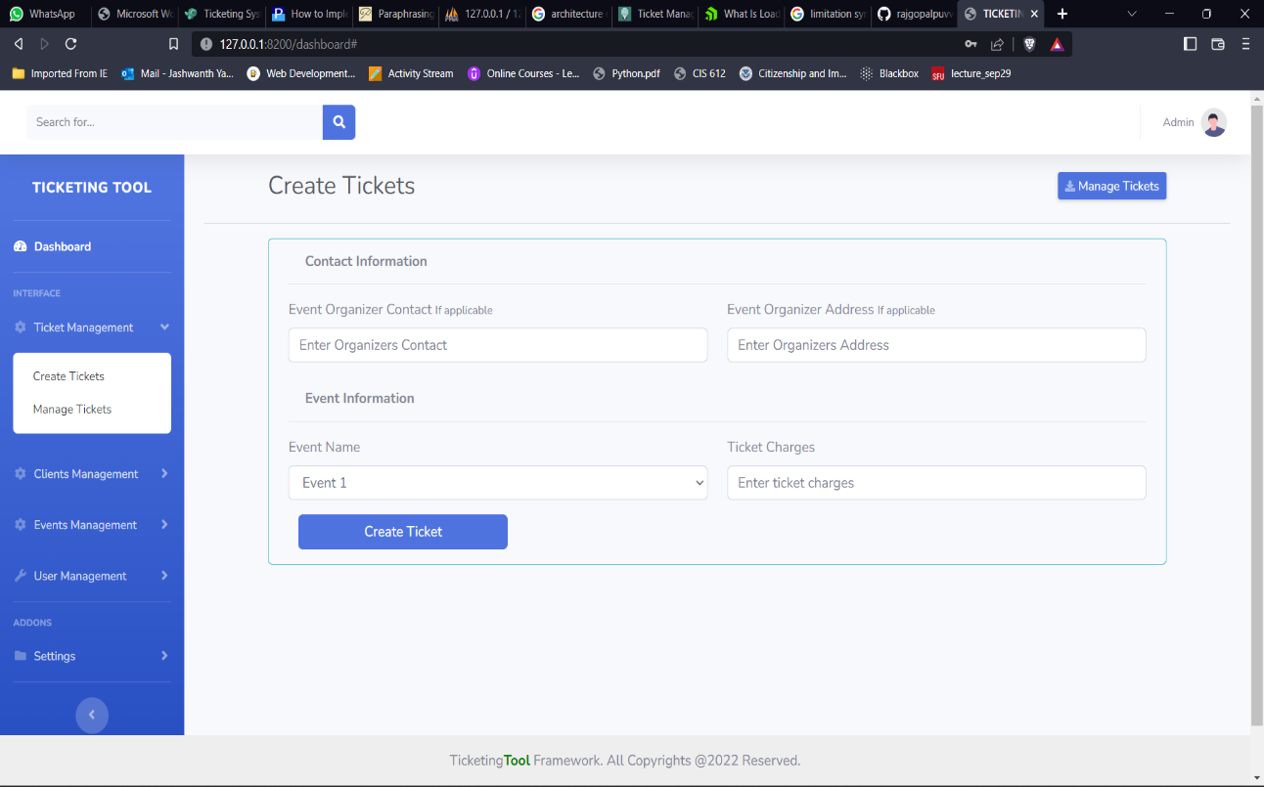
3.3 External Interface Description
Browser: A web browser that works with all browsers and has a seamless internet connection is required.

4.0 User interface design
Because this app is used by businesses, we kept the user interface clean and straightforward and included all the essential features necessary for effective outlets. The layout of the pages features a light color scheme and a navigation bar at the top that contains all of the information.
4.1 Description of the user interface
A help desk software tool called a ticketing system is used to manage and process client issues from submission to resolution.
Support inquiries are automatically categorized and prioritized in a central dashboard via ticketing systems. As tickets arrive, users can tag, classify, and allocate them. These systems also provide ticket status information so you can monitor open requests.
The use of ticketing software streamlines communication between agents and customers by acting as a central center for responses. Let's say a customer contact your company via Instagram. Without navigating to the social media app, an agent can reply to their message directly from the ticketing system. Or consider escalating a customer concern. An agent can move a support ticket to the appropriate person via a ticket escalation process and notify the client via the ticketing system.
In ticketing systems, shared inboxes encourage cooperation as well. Agents can eliminate silos by sharing client information among themselves.
Customer service managers can examine team performance measures including resolution time, response time, and first-reply time using ticketing systems. Even the frequency of consumer complaints can be tracked by ticketing systems, allowing you to pinpoint the issues that require attention.

4.2 Interface design rules
Any software product must have a functional user interface (UI). When done correctly, users are not even aware of it. Users can't get over it to effectively use a product when it's done poorly. Most designers adhere to interface design principles to maximize their chances of success when developing user interfaces. Software design is influenced by high-level notions known as interface design principles. I'll discuss a few guiding concepts in this essay. These are based on Bruce Tognazzini's Principles of Interaction Design, Ben Shneiderman's The Eight Golden Rules of Interface Design, and Jakob Nielsen's 10 Usability Heuristics for UI Design. The majority of the concepts can be used in interactive systems of any kind, including non-GUI interfaces (such as desktop and mobile apps, websites), typical GUI environments
The UI design principals are:
- Place users in control of the interface
- Make it comfortable to interact with a product
- Reduce cognitive load
- Make user interfaces consistent
5.0 Restrictions, limitations, and constraints
You can limit the number of appointments users can make per day, per week, per month, overall, or in the future, using any of the schedule kinds. When working with a membership system that allows just a certain number of appointments per member per week, for instance, such restrictions can be helpful.
Capacity schedules allow you to limit the number of bookings that can be made each slot in addition to these limits per user (default capacity per slot). You can also limit the number of times a space may be reserved concurrently by a single user. This option will add a "Quantity" field to the booking dialog, allowing users, for example, to indicate the number of seats they want to reserve, if you enter a value other than one.
By default, all users can see capacity information. Information about whether a slot is open or closed is displayed in its place if you opt to hide it.

You can choose to permit overbooking if you limit the number of available slots. A waiting list will be created for subsequent reservations after a slot is filled to capacity. Overbooking may be permitted for all users of your schedule or restricted to superusers and the administrator. If the latter, you may decide whether to automatically add users to the waiting list or to let users decide whether they wish to be added.

6.0 Appendices
You have complete choice over the priority levels you give a ticket. However, the following generic definitions may assist you in setting priorities for your setup:
- Low - Customer is not experiencing loss of functionality or system errors. For example, these may be general use questions, suggestions or future enhancement requests.
- Normal - Customer has loss of non-critical functionality. Customer can function and there are workarounds available. Customer issue may even be covered by existing documentation.
- High - Customer product/service is functioning in severely reduced capacity. Significant impact to the customer's operating and productivity. Potential loss of data or interruption of service.
- Critical - Customer product/service is completely down or not functioning. Customer has experienced loss of production data and no workaround is possible.
The severity of the customer's problem in the aforementioned scenarios determines the priority of the tickets. The importance of the customer or whether the ticket is much past due, for example, may have an impact on the priority that your business assigns to a certain issue.
All new tickets in the Service Desk start out with a priority level of "Normal." Setting ticket priority in Service Desk can be done in a number of different ways. By developing filters that apply actions to tickets with a specific priority level, you can also use priorities as a management tool.

6.1 Implementation issues
Email assistance presented various difficulties for both large and small businesses. The old ticketing systems, on the other hand, provided solutions for issues like workflow automation and boosting team efficiency.
However, we have all seen firsthand how the conventional system falls short of fulfilling these promises. A conventional ticketing system aids in moving client requests along, allows for prioritization of the most important tickets, collaboration, and reporting.
A ticketing system aids in grouping and handling requests. answering questions, optimizing procedures, and responding to client demands.
A ticketing system makes it possible to automate workflows, report on activities, collaborate, set priorities, and do many other things.

- Complication
Systems for traditional ticketing have various capabilities. The problem with them is that because they do so many things, even the simplest activities end up being much more difficult than they need to be.
- Slow
The most common complaint from users of traditional ticketing systems is that it is too sluggish. The typical ticketing system tends to become slower since it performs so many functions. It makes using a standard ticketing system much more difficult than it must be.
- Customizable
The system is chaotic and difficult to administer due to its many rules and routines. Today's consumer attention, however, would be impossible to handle with a slow system and would become complicated with several workflows.

- Usage is a challenge
Users find it much more difficult to make requests when there are several forms and complicated procedures.
- No integration
Traditional ticketing systems offer separate systems for internal support, external support, and production issues, for example, slack for chat and an intranet portal for HR.
- Impersonal
A traditional ticketing system does not understand the severity of a problem and treats them all the same. It responds to the most simple and complex issue with the same reply saying someone will revert in the next twenty-four hours.
- Action of every action
A standard ticketing system's procedure can overwhelm the support staff with frequent requests, such as a password reset or a troubleshooting problem. In addition, it causes the employees to be less motivated and dissatisfied.
- Delay
Adding a knowledge base helps the support team search for a canned response and insert it when they receive similar requests.

